Applied Operations Research Term Project

first report ABOUT the project

* ALEYNA KURTKAYA
* İREM KOÇ
* PINAR GİZEM CULHA

2022

Queuing theory is a theory that emerged as a result of the incoming customer demands for service not being met immediately. In line with the queuing theory, the topic we have chosen is “insufficient means of transportation as a result of the increase in the school population”. Transportation has become one of the most common problems today, and it is a problem that is more common and needs to be solved, especially in big cities such as Izmir. While choosing our project topic, we considered the areas where people have the most problems and decided that the places where queues occur most frequently are “banks, hospitals, public transportation areas”. Among them, we chose public transportation. First of all, we need to determine why public transportation vehicles are insufficient.

* A sudden increase in the population
* Long arrival times of public transportation vehicles
* Insufficient number of public transport vehicles

Such reasons often lead to the formation of increasingly long queues. Waiting in line for minutes cause disruptions in daily life for people. People who need to go to work, school or anywhere have to wait in long queues and are not satisfied with the service provided. The methods that can be applied to solve these problems can be listed as follows;

* Increasing public transportation vehicles
* Arrangement of arrival times

In this project, based on a more specific region, we chose as a subject the inadequacy of public transportation vehicles and the long queues as a result of the increase in the population of Bakırçay University over the years. Although there is no traffic or road problem in this region, the inadequacy of public transport and the crowded population cause long queues. In order for people to go to school, they either have to come early and get in line or they risk being late for class. This makes our daily life more stressful. In line with the analyzes we will make in our project, we will try to find the most suitable solution for both students and the transportation system.

In line with all these, we will proceed through Excel to solve our problem.

At the first stage, we will collect the necessary data. These data are:

|  |
| --- |
| * *Poisson/ Customer arrival rate per min, λ* |
| * *Exponential/ Service rate per server, μ* |
| * *Number of servers, c* |

For our intermediate calculations, the following headings are required:

|  |
| --- |
| * *Average time between arrivals* |
| * *Average service time per server* |
| * *Combined service rate, c x mu* |

For the performance measures, we will take the performance measures in the queuing theory as a basis.

|  |
| --- |
| * *Average utilization rate, ρ* |
| * *Probability that there are no customer in the system/ P0* |
| * *Average number of customers in the system/ L* |
| * *Average number of customers waiting in the queue/ Lq* |
| * *Average time a customer spends in the system/ W* |
| * *Average time a customer spends in the queue/ Wq* |
| * *Probability that an arriving customer must wait for service/ Pw* |

For our project on how to improve the existing transportation system, we will evaluate the time transitions between the arrival process and the service process and try to produce solutions for times when customers are busy. These are the data measures we will use for the **Arrival process** and the **Service process**:

**For Arrival Process:**

* *Number of Customer*
* *The moment of Arrival System*
* *Time Between Arrivals*
* *Server idle Time*

**For Service Process:**

* *Number of Customer*
* *The Moment of the Service Started*
* *The Moment the service is over*
* *Service Time*

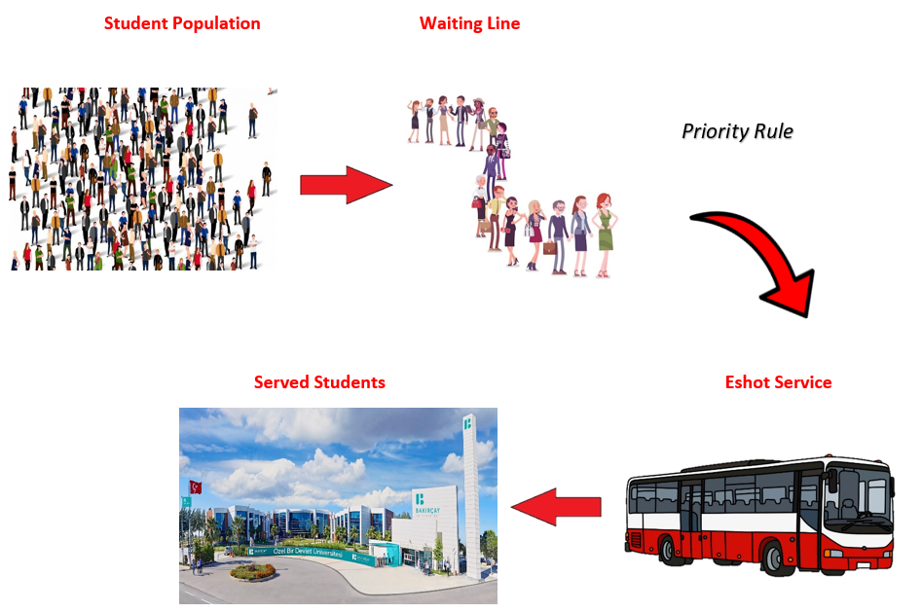 As a result of all these calculations, we will work on producing solutions according to the idle time of the server or the occupancy rate of the server.